Assembly instructions SIDBlaster-USB Tic Tac
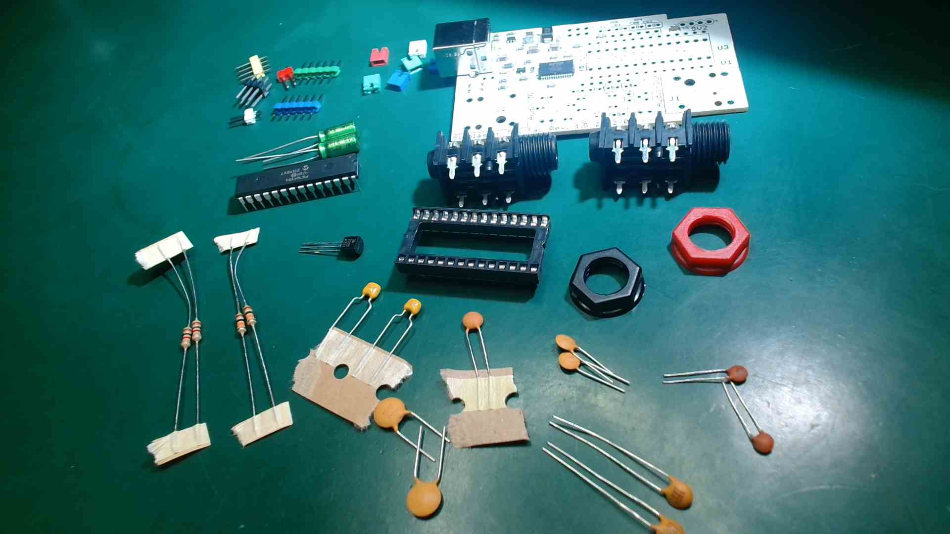
For the assembly, some experience in soldering is required. Under all circumstances, you’ll likely need:
- soldering station with a normal and a pointed soldering tip
- solder wire 0.7 and 1mm
- working lamp with magnifier
- flux pen
- hand suction pump
- tweezers
- small side cutter
- small flat or needle nose pliers
- isopropyl alcohol or denatured alcohol
- brush or toothbrush
- meter
- wooden toothpick
- Access to a Windows PC for the FTDI software to flashthe USB chip
Preparation:
Download the whole GitHub repository binary. (Clone it or download it as a zip file)

Assembly Steps:
Owners of a kit with a pre-assembled SMD part (Rev. 1.4) start at point 16.
Owners of a kit with a pre-assembled SMD part (Rev. 1.5) start at point 18.
- equip FT232 chip (U2); the following pin numbers must be soldered up: 1; 4; 5; 7; 12; 14; 15; 16; 17; 18; 20; 21; 23; 25.
hint: subsequently check the right connections according to the circuit diagram with a multimeter ("wiring test")
Please note: For correct operation, pin 26 must be switched on mass. This was forgotten in the layout of revision 1.2. Therefore, bridge pin 25 with pin 26. This is fixed from revision 1.3
- equip LEDs D2: blue; D3: red; consider mark!
- equip R1 and R2, 270 Ohms
- equip C1, 10nFs
- equip U4, Imprint: B6287G; attention! U4 is turned by 180° in relation to U2
- equip C3, C4, C2, C21, C5, C6, C7, C20, C12(from Rev. 1.4): 100nFs
- equip R23 (18k)
- equip R22 (47k)
- equip R20 und R21 (1k)
- solder on inductor (L2), tip: tin-plate pads in advance
- solder diode D1 (SS26)
- Q1 (from Rev. 1.4) equip
- Equip R3, R4 (from Rev. 1.4) 1K
- Equip R5 (from Rev. 1.4) 10K
- clean circuit-board

- equip L1
- C10, C11 (22uFs), C13 (4,7µF)(from Rev 1.4) consider polarity
- equip USB jack socket
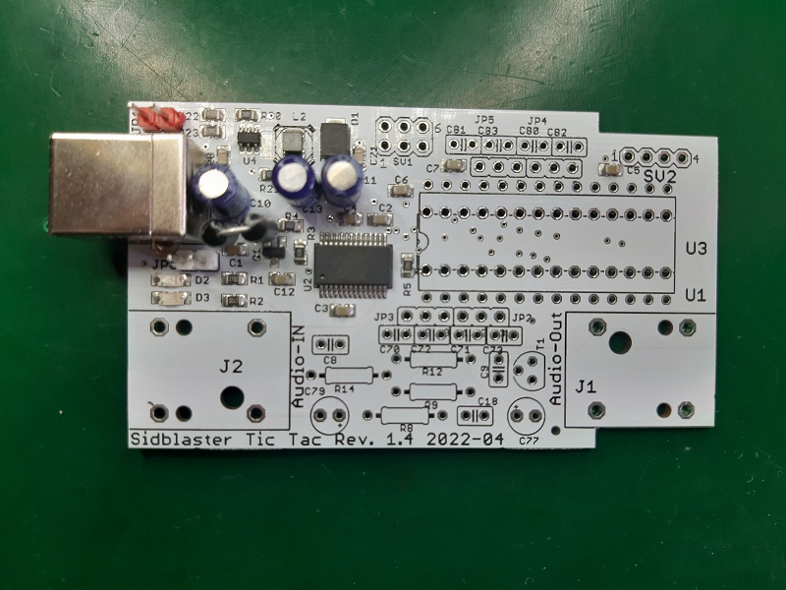
- test: connect current source, blue LED must be on; measure voltage between pin 14 (GND) and pin 28 (+12V) of U3 (SID)
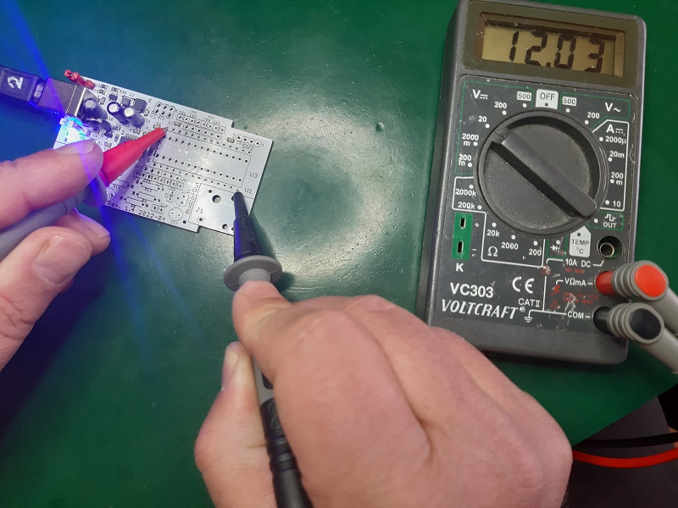
- equip JP1 (red) and JP6 (white)
- Test: set JP1 and mesure voltage at the SID socket (must be 9V now)
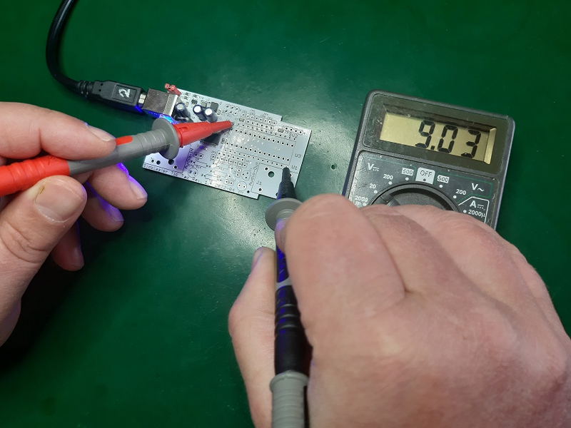
- solder on U1, pinch off spare ends
- IC socket for SID: cut connections with side cutter, sand smooth
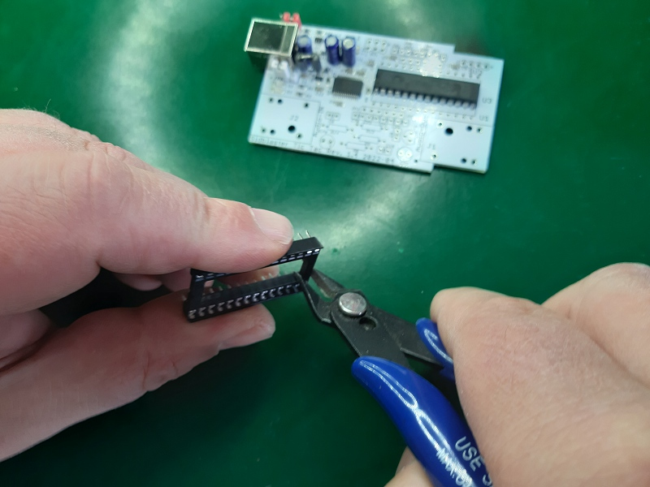
- solder in the two parts of the socket
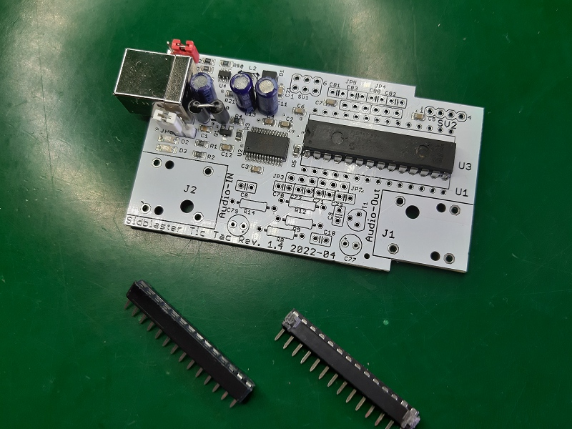
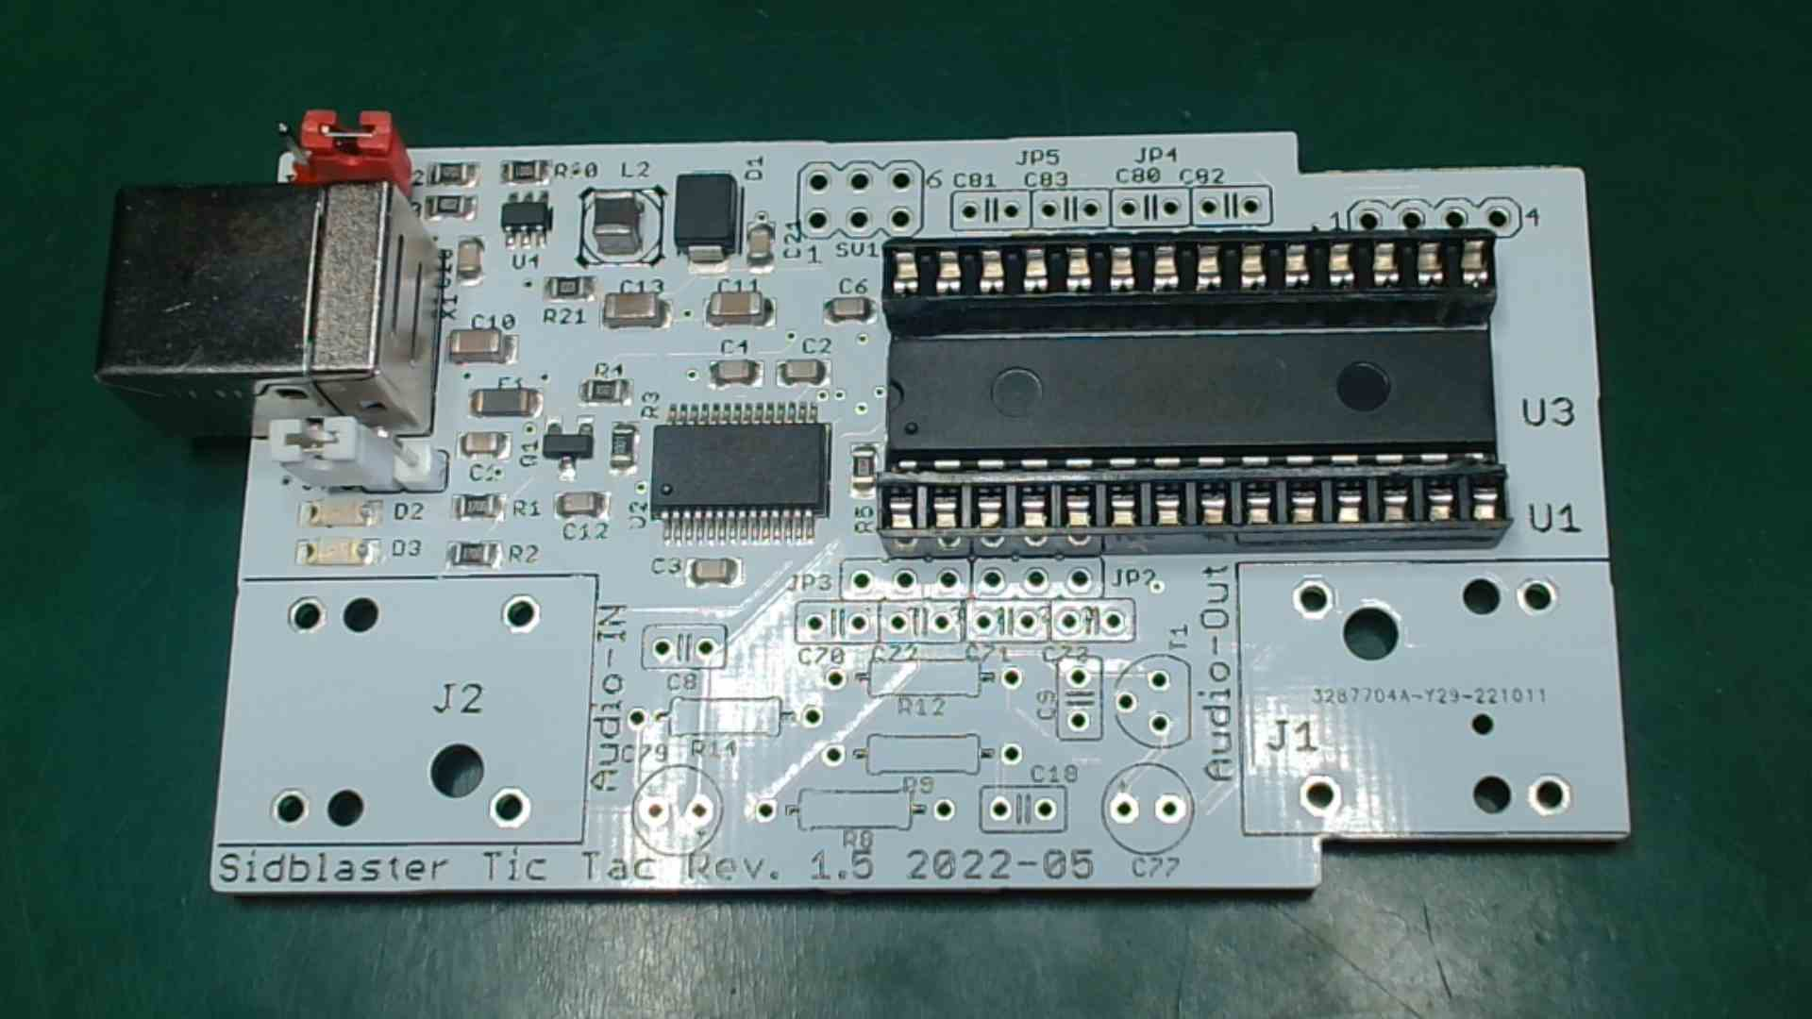

- flash FT232 template: software tool "FT_Prog" by FTDI required. Connect circuit board, start FT Prog, scan for device, load template (GitHub), right click on Device ->Apply Template. Then click "program" and program. Attantion! New template for Rev. 1.4!
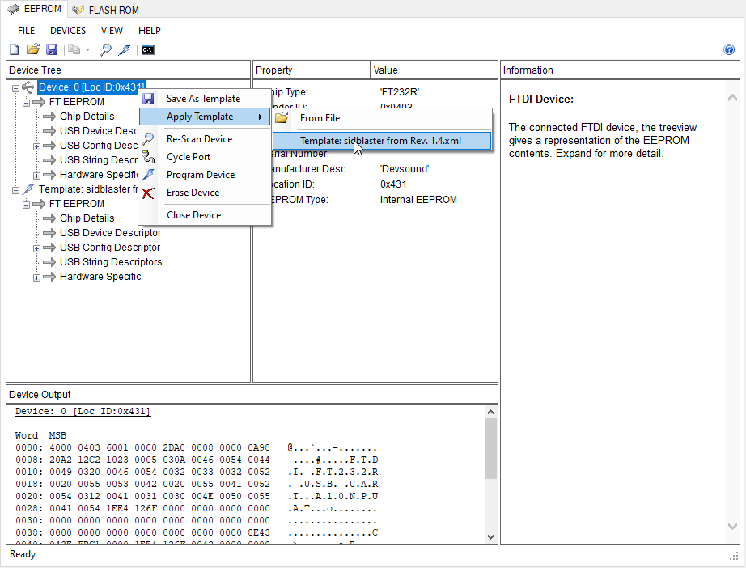
- equip SV1
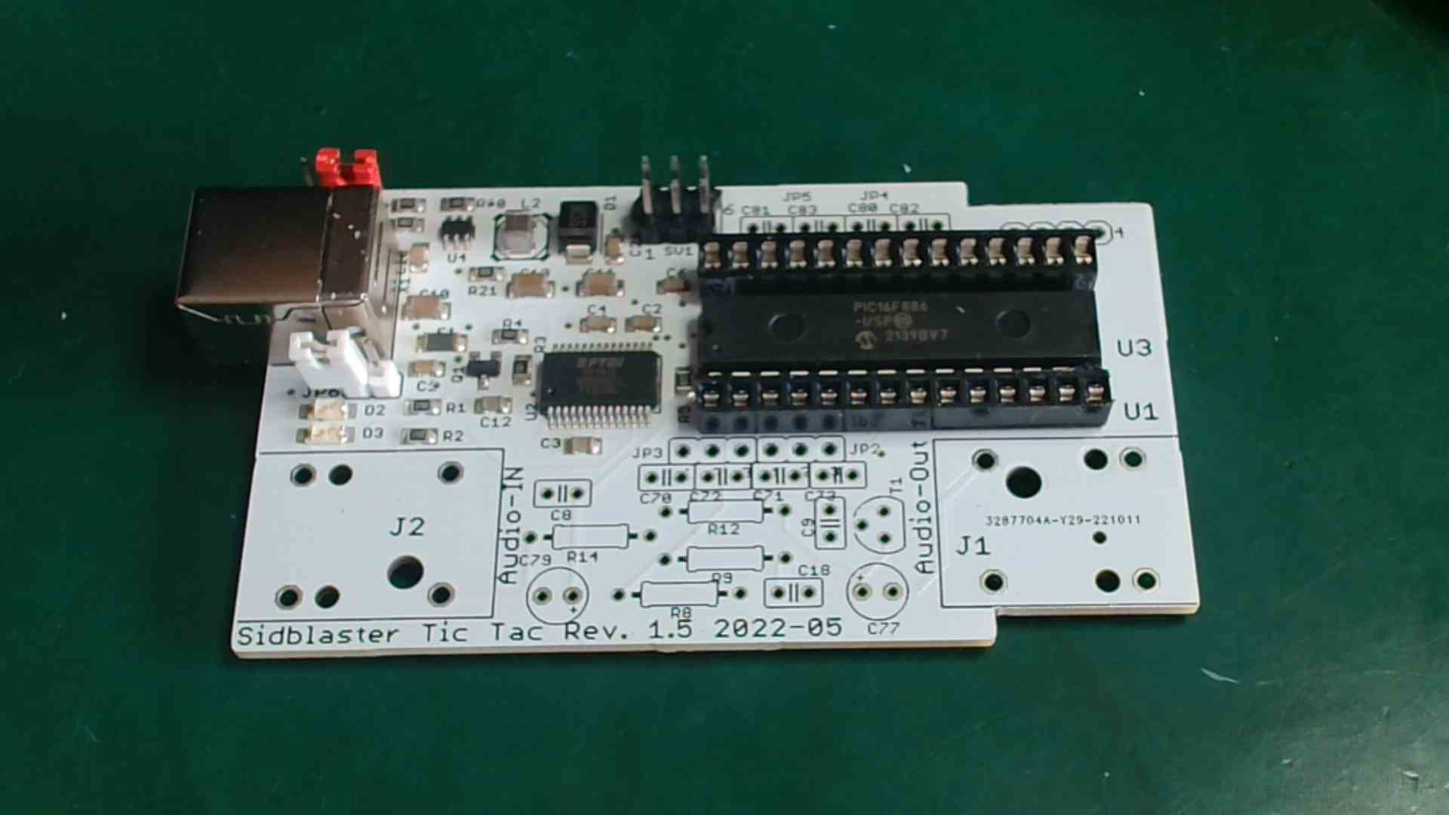
- flash PIC µC: A programming device like PicIt 3 is needed, possibly build adapter cable (see manual), software: MPLAB IPE. Kit customers receive a pre-programmed PIC.
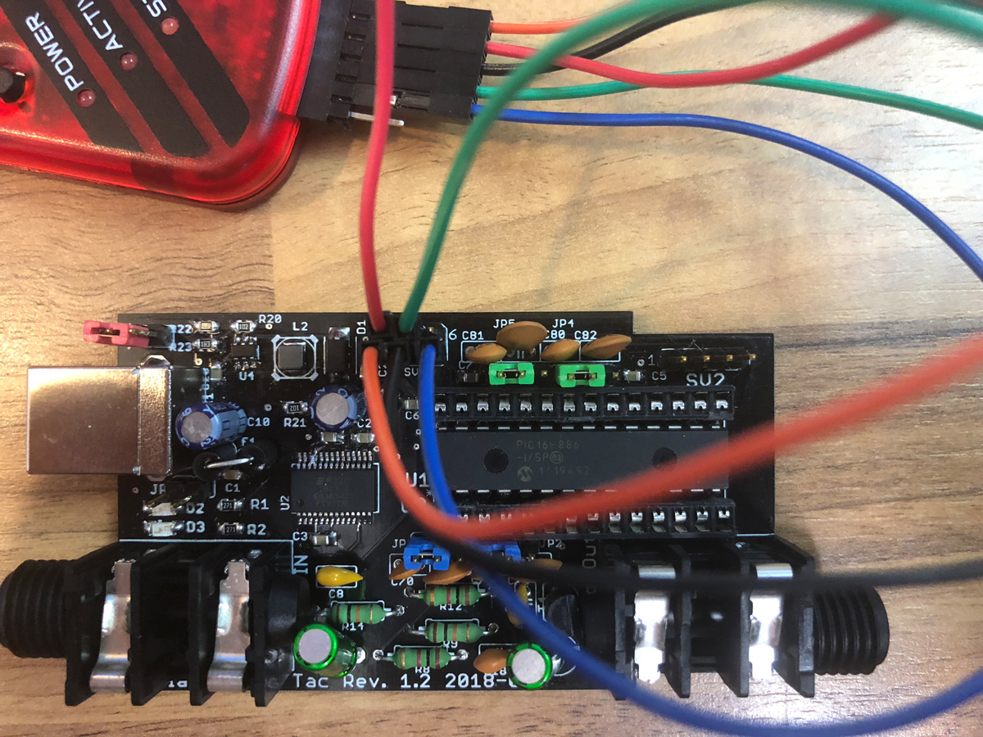
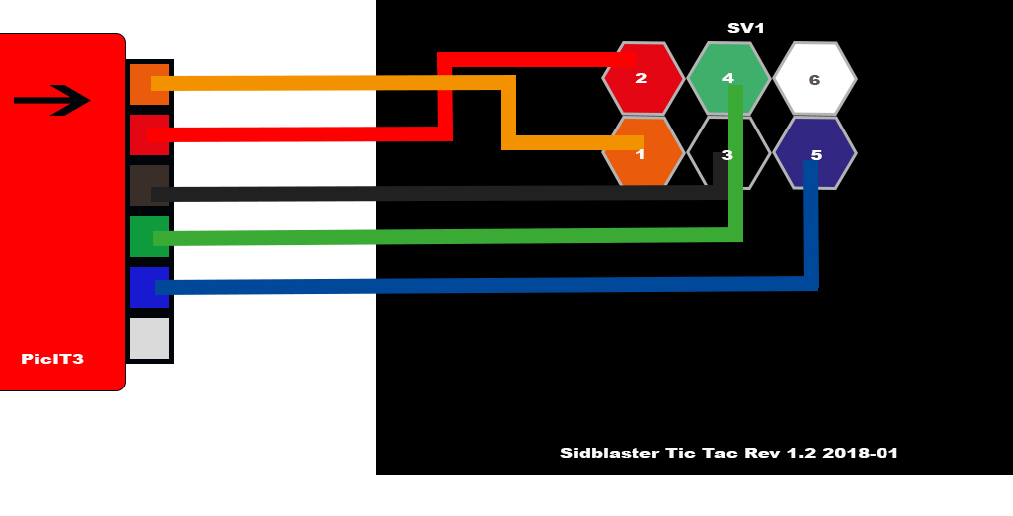
- Test: Connect board and start ACID 64 Player (Version 3.6.3; copy hardsid.dll (32Bit (In folder hardsid_library in GitHub Repository)) to same folder before), play tune, SIDBlaster should be recognized, and red (green) LED flicker.
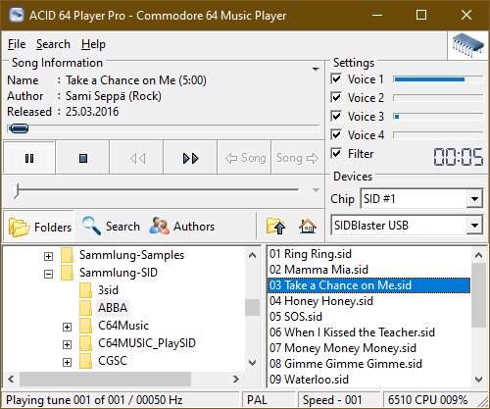

1. Note: It is best to equip 2 groups per blue (JP2&3) and green (JP4&5) pin strip with the associated capacitors and solder them together, otherwise holes could become clogged. If the holes get blocked, use a suction pump and toothpick.
2. Note: It is best to always solder strips and components to one pin first, so you have the convenient opportunity to correct the fit again.
- equip JP2 & JP3 (blue); JP4 & JP5 (green)
- equip SV2 (yellow)
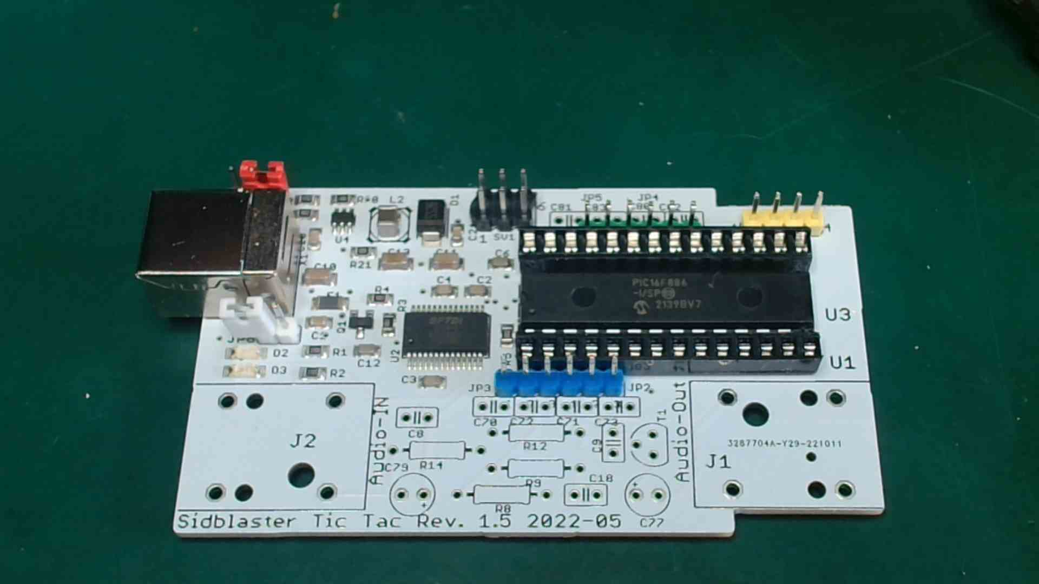
- equip C70, C71 (470pFs)(471)
- equip C72, C73 (22nFs) (223)
- equip C80, C81 (1800pFs)(182)
- equip C82, C83 (2,2nFs)(222)
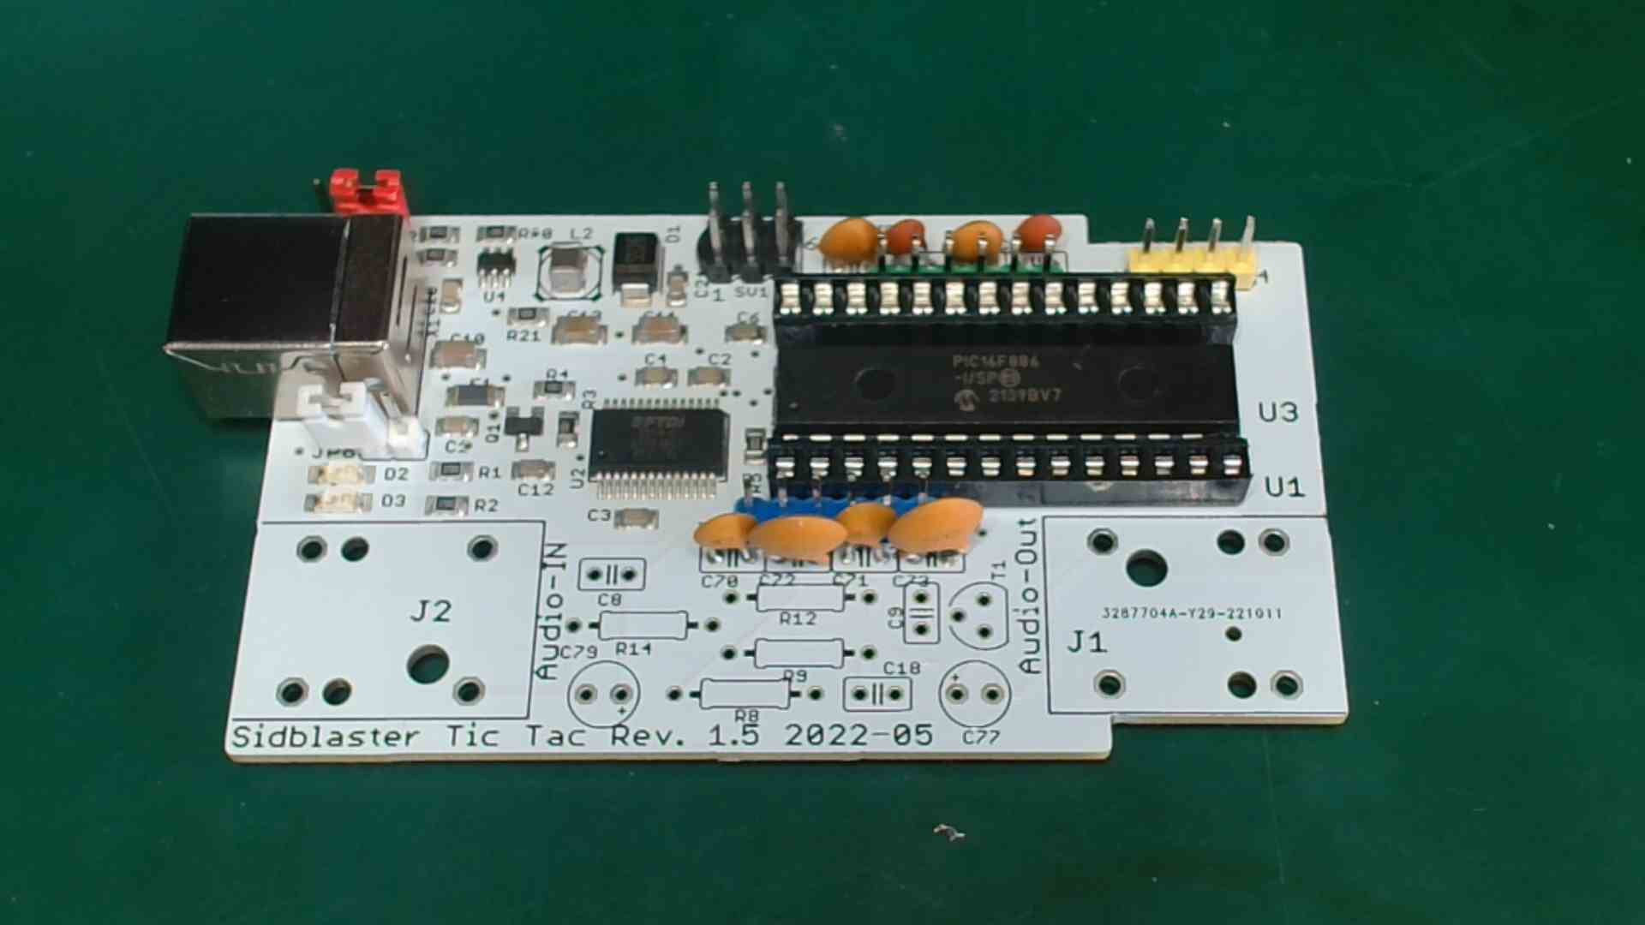
- equip R12, R8 (1K)(brown/black/red)
- equip R14, R9 (10K)(brown/black/orange)
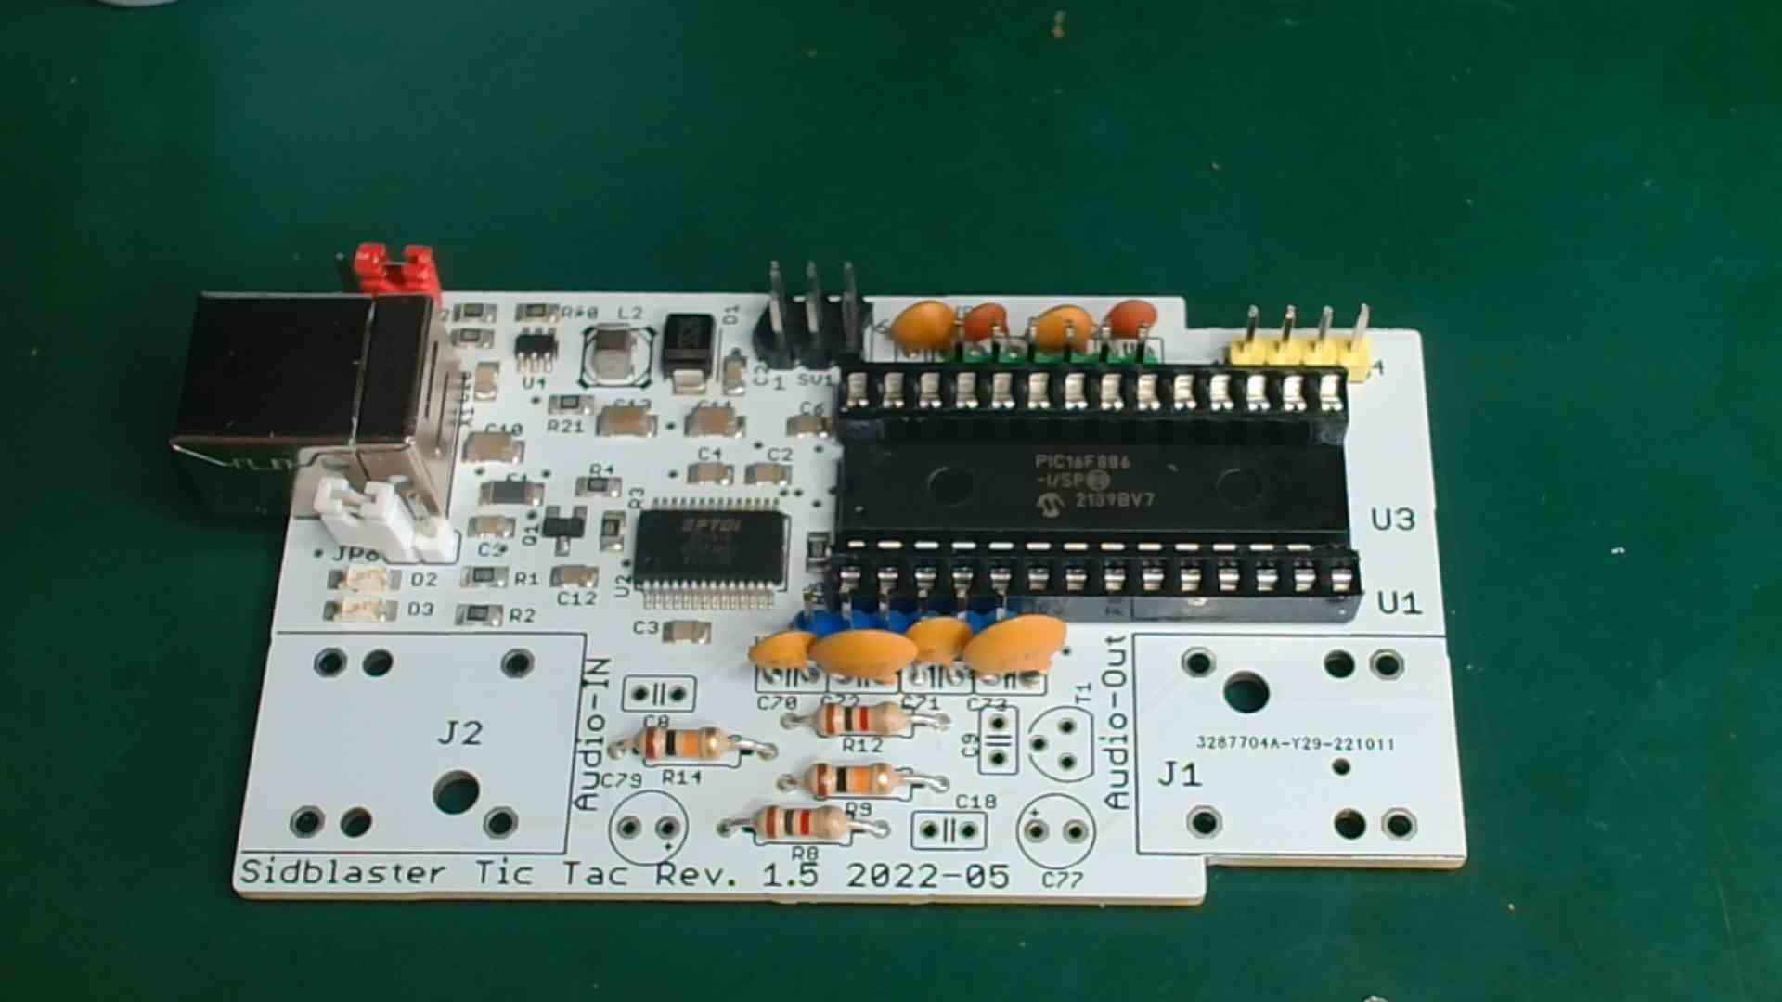
- equip C18 (1000pFs)(102)
- equip C8, C9 (100nFs)(104)
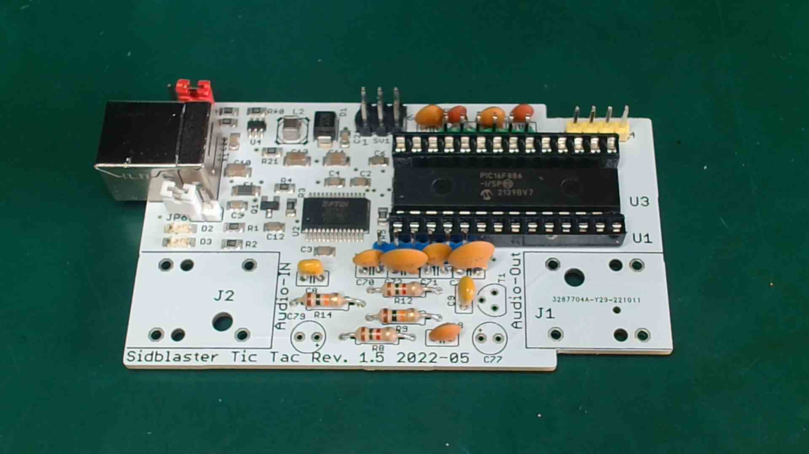
- equip T1, observe polarity according to data sheet! (May deviate from the equipment label!) With Rev.1.2 a PN2222A must be fitted the wrong way round, from Rev.1.3 the equipment label is right for PN2222A
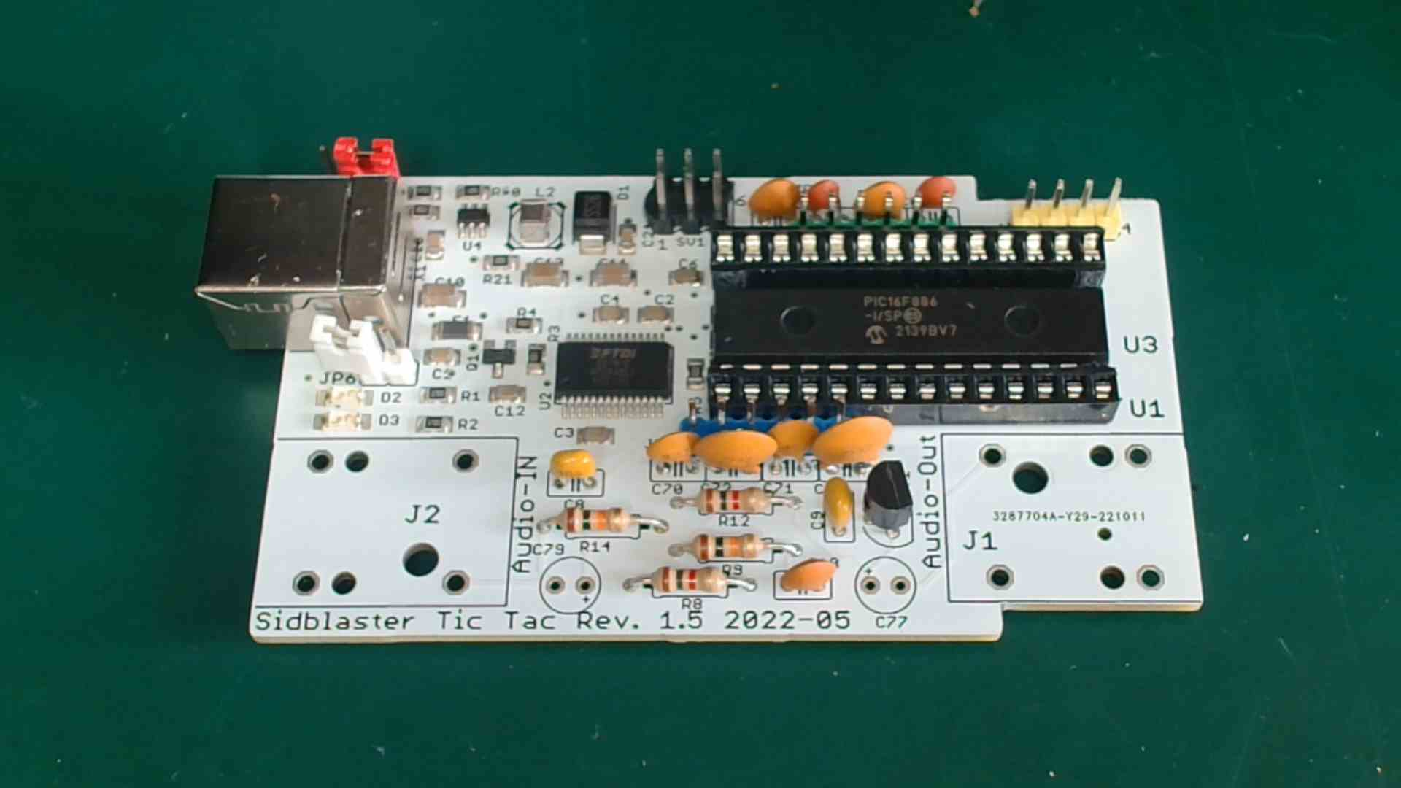
- equip C77, C79 (10uFs, bipolar), polarity irrelevant
- solder on jack sockets
- set jumper JP1: red; JP4 & JP5: green; JP2 & JP3: blue; JP6: white
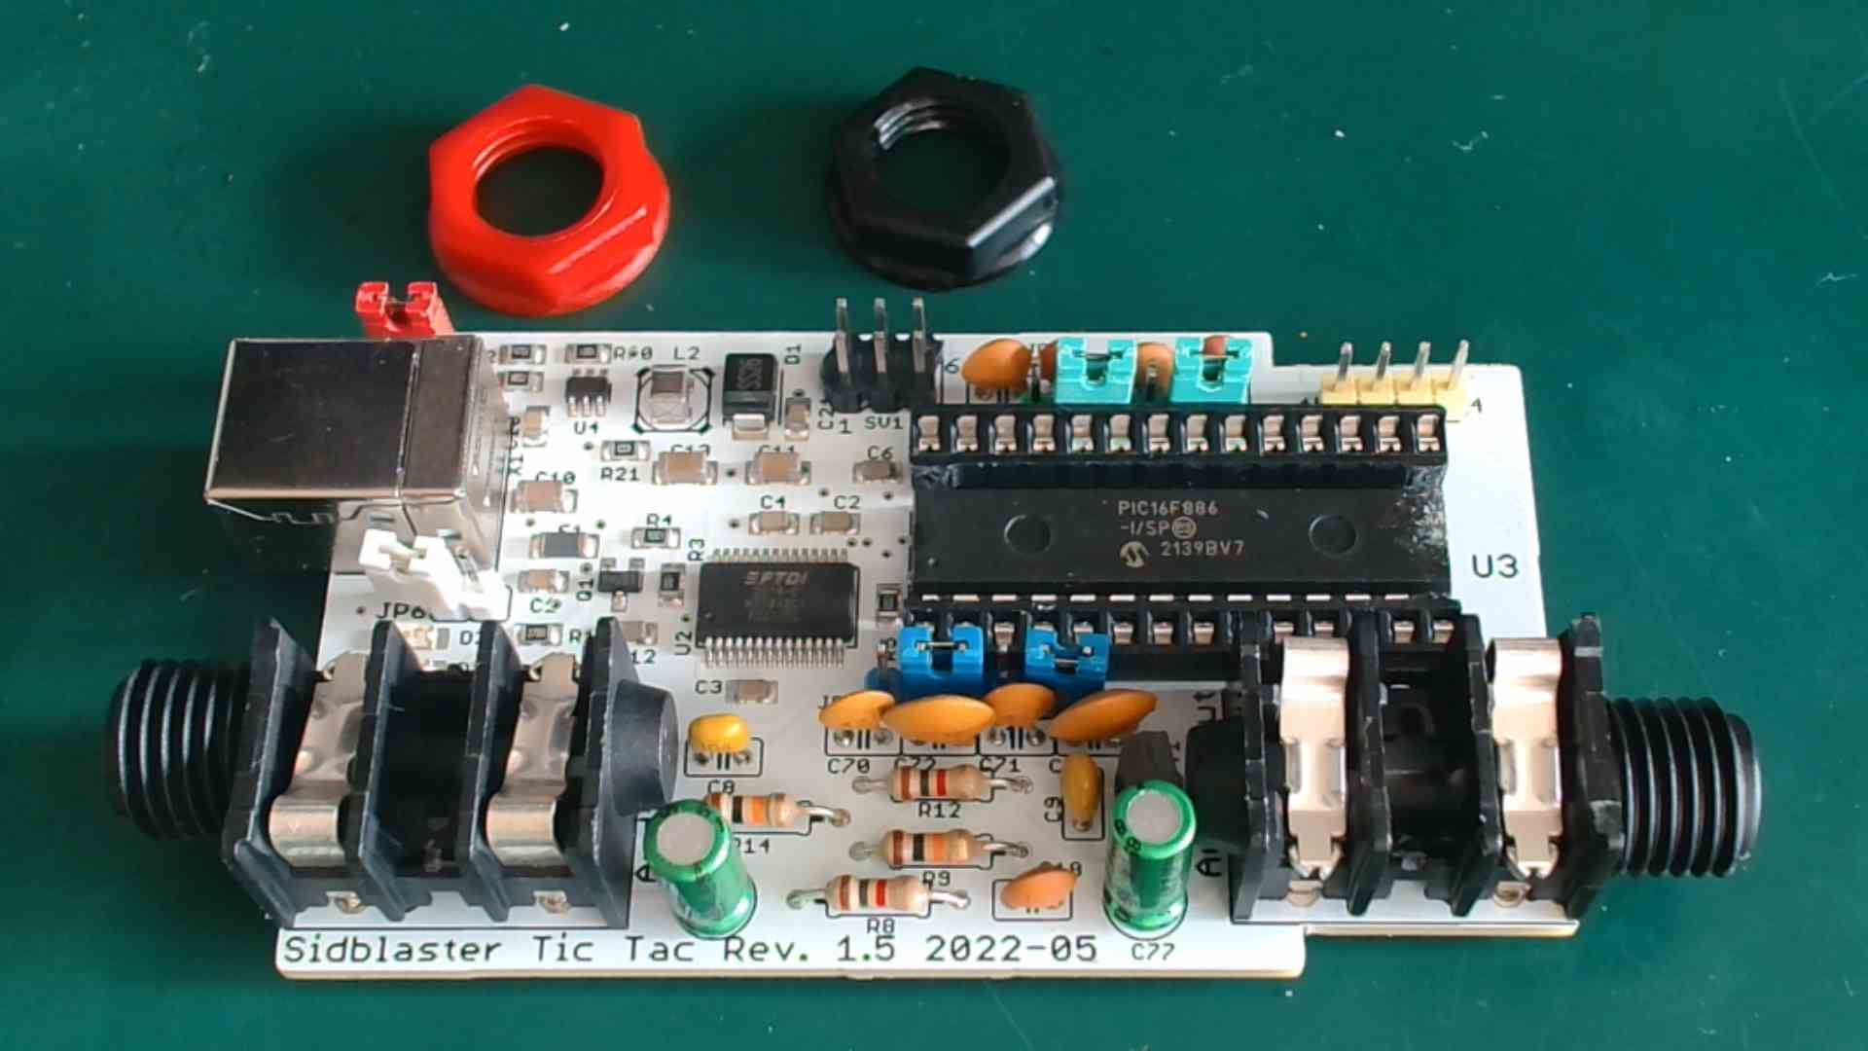
- clean the circuit board with a toothbrush and spirit and let it dry. I personally get the best results with denatured alcohol.
- measure voltages again
- install SID
- check jumper (see manual)
- connect to personal computer and test with ACID player (Version 3.6.3 with hardsid.dll, see above).

